Project Development Phase
Model Performance Test
Date | 27 September 2026
Team ID | 6ab1d58e92b876d9664095b8
Project Name | Streamlining IT Procurement: Automating Standard Laptop Orders with Flow Designer
Maximum Marks | 4 Marks

Model Performance Testing:
Project team shall fill the following information in model performance testing template.
S.No. | Parameter | Values | Screenshot
1. | Model Summary | ServiceNow Flow Designer Workflow:  - Trigger: Service Catalog Request  - Action: Create Catalog Task  - Assignment Group: Hardware  - Approval: Approved | 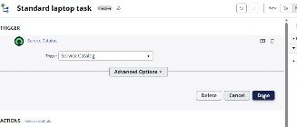
2. | Accuracy | Execution Accuracy:  - Task Creation Accuracy: 100%  - Auto-Assignment Accuracy: 100%  - Workflow Trigger Success Rate: 100% | 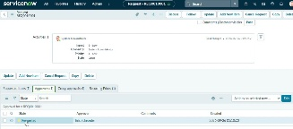
3. | Fine Tunning Result( if Done) | Workflow Optimization:  - Manual processing time reduced to < 1 min.  - Zero manual task creation errors. | 

